1. **Experiment:** LDH assay for measuring cytotoxic activity under acidic condition
2. **Time:** 2024.08.26-2024.08.31
3. **Member:** Xudong Tang, Yang Jin, Binxuan Zhang, Kaiqing Zhang, Xuantong Liu
4. **Materials:** K562 cell line, Microplate reader, CO2 incubator, LDH assay kit, 96-well plate, Pipette
5. **Method:**
6. Cell Preparation:
7. Seed K562 cells and previously proliferated NK cells into culture dishes with the appropriate medium. For the experimental group, use medium supplemented with 15 mM lactic acid to adjust the pH to 6.4; for the control group, use medium with pH 7.4. Incubate at 37 ℃ with 5% CO₂for 36 h. Change to a fresh medium the evening before the experiment.
8. Cytotoxicity Assay:
9. Prepare a 96-well round-bottom plate for the cytotoxicity assay. Conduct experiments at E: T ratios of 1:1, with replicates per ratio. Add effector and target cells to each well, with a total volume of 100 µL per well.
10. Set up control wells: Natural release control wells with the same number of effector cells as in the experimental wells. Maximum release control wells with the same number of target cells, adding medium to achieve a final volume of 90 µL per well. Natural release control wells for target cells, adding medium to achieve a final volume of 100 μL per well. Background control wells with 100 μL of CAR-NK cells.

**Table1**. Experimental wells and control wells set

|  |  |  |
| --- | --- | --- |
| **Wells** | **Cell types** | **Volume (per well)** |
| Experimental Wells | Effector and target cells | 100 μL |
| Natural release control wells | Effector cells | 100 μL |
| Maximum release control wells | Target cells | 90 μL |
| Natural release control wells | Target cells | 100 μL |
| Background control wells | CAR-NK cells | 100 μL |

1. 10 μL of sterile ultrapure water was added to the spontaneous release control wells for both effector and target cells. Spontaneous release control wells were built to reduce the interference of non-specific release from cells under normal culture conditions on the experimental results.
2. The plate was incubated at 37 ℃ with 5% CO₂for 4 hours.
3. 10 μL of lysis buffer was added to the Maximum Release Control wells and incubated for 45 minutes.
4. The plate was centrifuged at 250 g for 3 minutes. 50 μL of supernatant was transferred from each well to a corresponding flat-bottom plate. 50 μL of reaction substrate was added to each well and incubated in the dark at room temperature (25 ℃) for 30 minutes. Once color developed, 50 μL of stop solution was added to each well and the plate was mixed gently
5. A microplate reader was used to measure the absorbance at 490 nm and 680 nm. Subtract the absorbance value at 680 nm (background signal) from the absorbance at 490 nm (D).
6. For accurate calculations, the average Background Control value was subtracted from the average experimental value, the Effector Cell Spontaneous Release Control value, and the Target Cell Spontaneous Release Control value.
7. The NK cell killing rate (%) was calculated using the following formula:

NK killing Rate (%) = $\frac{Exp OD - Eff Spont OD - Tgt Spont OD - Bkgd Avg}{Max Release OD - Tgt Spont OD}×1$ 00%

Lysis Rate (%) = $\frac{Exp LDH - Tgt Spont LDH}{Max Release LDH} ×100\%$

1. **Result:**

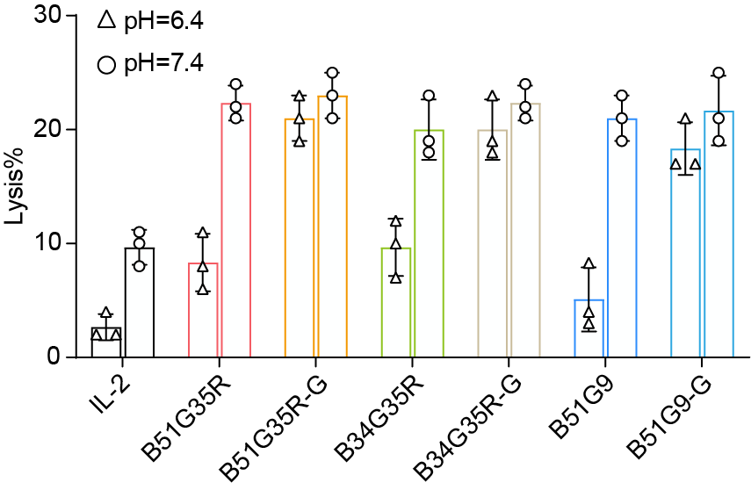

**Figure.1** Lysis detection of NK cells pre-activated by IL-2, B51G35R, B51G35R-G, B34G35R, B34G35R-G, B51G9, B51G9-G separately at both pH=6.4 and pH=7.4. Data are representative of at least three independent experiments (\*\**P* < 0.01, \**P* < 0.05).